Influence of a western boundary current on cross shelf patterns in zooplankton

(A title should be specific, informative, and brief. Capitalize major words in titles, but not conjunctions and articles. Use abbreviations only if they are defined in the abstract. Titles that start with general terms then specific results are optimized in searches—delete these notes when done)

**Hayden T. Schilling1,2, Amandine Schaeffer3, Jason D. Everett2, Peter Yates1,2, Mark Baird4, Iain M. Suthers1,2**

1Sydney Institute of Marine Science, Chowder Bay Road, Mosman, New South Wales, Australia

2Centre for Marine Science & Innovation, University of New South Wales, High Street, Kensington, New South Wales, Australia

3School of Mathematics and Statistics, University of New South Wales, High Street, Kensington, New South Wales, Australia

4Commonwealth Scientific and Industrial Research Organisation, Castray Esplanade, Battery Point, Tasmania, Australia

(Affiliations should be preceded by superscript numbers corresponding to the author list. Each affiliation should be run in so that the full affiliation list is a single paragraph.)

Corresponding author: Hayden T. Schilling ([Hayden.Schilling@sims.org.au](mailto:Hayden.Schilling@sims.org.au))

Key Points:

* List up to three key points (at least one is required)
* Key Points summarize the main points and conclusions of the article
* Each must be 140 characters or less with no special characters or acronyms.

(The above elements should be on a title page)

Abstract

Western boundary currents are known to influence continental shelf waters through a variety of physical mechanisms. Despite this, understanding of how western boundary currents influence the biota on the continental shelf is limited. Zooplankton are the basis for many pelagic ecosystems yet it is largely unknown how the East Australian Current influences the zooplankton community on the continental shelf. By combining 4 targeted cross-shelf transects from inshore to off the continent shelf in Australia with an analysis of satellite derived sea surface temperature, we show that there is a regularly occurring EAC driven inshore – offshore temperature gradient on the continental shelf of eastern Australia which corresponds to changes in the zooplankton community. Zooplankton biomass, abundance and geometric mean size generally declined with increasing distance from the coast and depth when the EAC was influencing the coastal water on the continental shelf through uplift of cooler nutrient rich water. This cooler water also had a steeper normalized biomass size spectrum slope, signifying that this is highly productive water. This highly productive band of inner shelf water may be contributing the consistently high yield from fisheries in this region. This influence of the EAC on continental shelf zooplankton is likely reflected in other western boundary current regions where fast flowing currents influence water on the continental shelf though uplift of colder water. Combined with previous research, inner continental shelf regions appear to be highly productive and support high biomass of zooplankton around the world, suggesting this inner shelf water a widely occurring phenomenon.,

The abstract should be a single-paragraph of less than 250 words, or for *Geophysical Research Letters*, less than 150 words. A good abstract sets the general question or topic that you are studying for the general reader, provides background on the specific question or problem, briefly describes key data or analyses, and describes the key results and uncertainties. Please avoid acronyms or if used, define them.

**Plain Language Summary**

This is optional but will help expand the reach of your paper. Information on writing a good plain language summary is available [here](http://sharingscience.agu.org/creating-plain-language-summary/).

1 Introduction

Western boundary currents (WBCs) are fast-flowing currents which transport warm salty water from low latitudes poleward. As they flow along continental boundaries they generally inhibit cross-shelf transport due to their strong along shore flows (*Roughan et al.*, 2011). At a more local scale, WBCs interact with the continental shelf to generate eddies, fronts and upwelling. These features increase transport across the continental shelf (*Malan et al.*, 2020). By increasing mixing and uplift of cold water on the continental shelf, WBCs are contributing to production through the supply of nutrients normally found in the deeper water (*Pereira Brandini et al.*, 2014).

Within uplift dominated systems such as western boundary currents, zooplankton have been shown to have important keystone roles (*Libralato et al.*, 2006). This role includes transferring energy to fish (*Champion et al.*, 2015; *Marquis et al.*, 2011) as well as linking the benthic and pelagic zones. It has been estimated that zooplankton support up to 53 % of fish biomass on temperate coastal reefs (*Truong et al.*, 2017).

Size is an important trait in pelagic systems with predator-prey interactions usually driven by size (*Barnes et al.*, 2010). By focusing on the size distribution of the zooplankton community complex species specific dynamics can often be simplified. One method of analyzing the size structure is through the normalized biomass size spectrum (*Kerr and Dickie*, 2001). Using a linear fit of normalized biomasses in logarithmically equal size bins, the structure of the zooplankton community can be quantified, with a general overall slope of -1 observed in the open sea (*Baird et al.*, 2008). A steeper slope with large amounts of small particles generally infers higher production while a shallow slope often represents lower predation and less ‘top-down’ pressure (*Blanchard et al.*, 2017).

The distribution of zooplankton is the result of a number of factors including physical mechanism such as transport and retention, biological factors including prey availability and predator abundance as well as behavior of the zooplankton (*Huntley et al.*, 2000). It has previously been observed that zooplankton are not distributed uniformly across continental shelf with oceanographic features a key factor in these distributions. In the southeast Atlantic it was shown that the zooplankton community on the continental shelf had higher biomass and a steeper Normalised Biomass Size Spectrum (NBSS) slope compared to the offshore oceanic stations which were typically more vertically stratified (*C d R Marcolin et al.*, 2013). This is similar to other studies in the northeast Atlantic where high zooplankton biomasses and steeper NBSS were found in some but not all inshore regions with the majority of high productivity areas located along the French coastline with productivity and biomass decreasing in offshore areas (*Irigoien et al.*, 2008; *Sourisseau and Carlotti*, 2006; *Vandromme et al.*, 2014). This onshore-offshore gradient in biomass has also been observed in the southwest Atlantic where it was identified that vertical distributions of zooplankton on the continental shelf are likely related to water masses (*Pereira Brandini et al.*, 2014). Few studies have explicitly examined patterns of zooplankton with depth on continental shelfs. Off New York, during late summer it was observed that total zooplankton abundance was higher at depth close to the coast (< 50 m bathymetry) with smaller effects seen offshore (> 50 m bathymetry; *Turner and Dagg*, 1983). This is contrasted by a winter study on the Abrolhos Bank where on the shelf, copepod abundance peaked near the surface (20 – 40m) and decreased with depth (*C Marcolin et al.*, 2015). On the other hand, light availability and predation by fish is thought to be a significant driver of zooplankton depth distributions in the Barents Sea (*Aarflot et al.*, 2019).

The East Australian Current (EAC) is a baroclinic jet which forms between 10 and 20 °S when the South Equatorial Current diverges against the Australian coast. It flows south at approximately 0.5-1 m s-1 flowing the continental shelf (Archer et al., 2017) until the majority of the EAC separates from the coast at approximately 30 – 32 °S and continues to flow eastward as the EAC eastern extension (*Cetina-Heredia et al.*, 2014; *Oke et al.*, 2019). The remaining portion of the EAC continues to flow south along the coast as part of the EAC southern extension generating a large eddy field. Along the continental shelf, particularly in the where the continental shelf narrows, the EAC had significant impact on shelf circulation (Schaeffer et al. 2013). Current driven bottom friction leads to Ekman transport in the bottom boundary layer, moving cooler denser water up the slope, resulting in uplift of isotherms and upwelling (Schaeffer et ql 2014). These upwelling events have been shown to bring nutrient rich water into the euphotic zone, increasing primary productivity (*Rossi et al.*, 2014) and controlling vertical phytoplankton abundance, composition and distribution (*Linda H. Armbrecht et al.*, 2014; *L. H. Armbrecht et al.*, 2015). Phytoplankton and nutrients are a key energy source for zooplankton and it is highly likely that the variable EAC is influencing zooplankton communities similar to the phytoplankton communities. Despite this there is little information on how western boundary currents influence depth distribution of zooplankton on the continental shelf around the world and no analyses in the EAC continental shelf region. This study therefore aims to investigate cross shelf and depth stratified patterns of zooplankton on the east Australian continental shelf and identify the temporal stability of any observed patterns.

2. Materials and Methods

2.1 Voyage details

The cruise took place at the beginning of the austral spring, in September 2004 on the *RV Southern Surveyor*. At this time, the EAC had separated from the coast at approximately 31°S and formed a large pool of water at 33°S, 155°E, creating a counter-clockwise rotating warm core eddy (Fig 1).

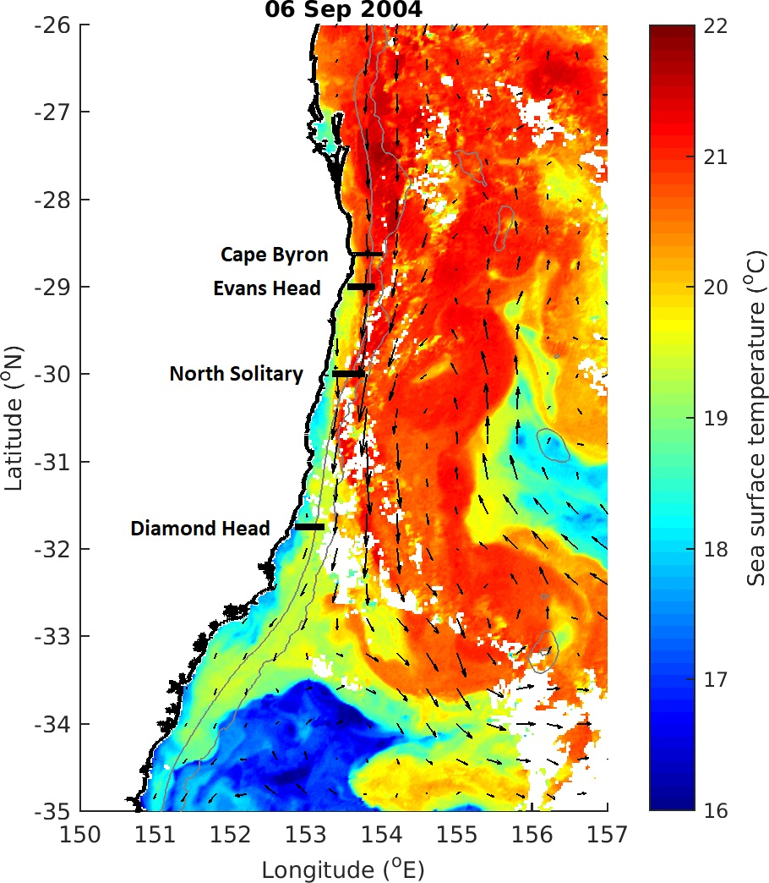

Figure 1. Locations of the 4 cross shelf sections which were sampled in September 2004. The sea-surface temperature for 6th September 2004 is shown in colour with velocity arrows from satellite altimetry shown with black arrows.

2.2 Sampling

Five sections were sampled along constant latitude transects roughly perpendicular to the north NSW coast over a 6 day period in September 2004. Four of these sections used a CTD and 4 sections used a towed device called the Bunyip (a highly modified SeaSoar) with 3 sections using both the CTD and Bunyip. During the CTD transects, florescence, temperature, salinity and oxygen were electronically measured, and nutrients (NO3, PO4, Si) and bottle oxygen taken at the surface, and, total depth of water allowing, at depths of 25, 50, 75, 100, 150, 200, 250, 400 and 500 m. Filtered particulate matter samples were taken at the surface of each of the CTD stations. The Bunyip was towed from inshore to offshore and varied between the 10 and 120 m, sampling temperature, salinity, and, using an optical plankton counter (OPC; *Herman*, 1992), the size distribution of particulate matter. The ship was also equipped with an ADCP which continuous monitored the velocity of water beneath the vessel with alongshore velocity of currents calculated by rotating the U and V vectors to account for the angle of the coastline at each location. This paper will focus on the four sections which were analysed with the OPC. The CTD transects and further sampling during this period using towed plankton nets will be reported in later publications. The shelf sampling was interrupted on the 8-10th September to undertake a wake study around North Solitary Island (29°55'S 153°23'E) which will be reported elsewhere. All times reported are local (Sydney) Australian eastern Standard Time.

2.2.1 Sections

The 4 sections which were analysed using the OPC were as follows:

Diamond Head Section (31°45'S). The Bunyip undertook a transect between 1953-2201 on the 6th September in an easterly direction, followed by net tows in a westward direction. A CTD transect was then undertaken in an easterly direction on the 7th September from 0437-0838.

North Solitary Island Section (30°00'S). The Bunyip undertook a transect between 2134 on the 7th September and 0013 on the 8th in an easterly direction, followed by net tows in a westward direction. A CTD transect was then undertaken in an easterly direction on the 8th September from 1340 -2314.

Evans Head Section (29°00'S). A Bunyip transect was undertaken in an easterly direction from 1048-1243 on the 11th September. A CTD transect followed in a westward direction from 1317-2044 on the 11th September, and finally net tows.

Cape Byron Section (28°38'S). A Bunyip transect was undertaken in an easterly direction from 0805-1006 on the 12th September. No other sampling was undertaken at Cape Byron.

3 Data, or a descriptive heading about data

Satellite Data (From Iain’s Paper – needs rewording)

MODIS Level 3 sea surface temperature and ocean-colour data (chlorophyll-a) were obtained from the Integrated Marine Observing System (IMOS) Data Portal (<http://imos.aodn.org.au/imos/>) at 1 km resolution. Chlorophyll-a was derived using the OC3 algorithm. MODIS data were retrieved for 5x5 pixels (~25 km2) surrounding the centre of each sample, on the day of sampling. Based upon the start and end locations of our voyage transects, SST and Chlorophyll-a data was downloaded for a ten year period (2004 – 2013) for both the inshore (15km from coast) and offshore (45 km from coast) for each transect to provide context to the observed temperatures during the voyage. A 5km from coast site was also investigated to determine the sensitivity of the choice of distance from coast for the inshore location. Satellite altimeter data were obtained from NASA/CNES (Jason-1 and 2) and ESA (ENVISAT) and mapped in near-real time for the Australian region. As the resolution for altimetry is much courser than MODIS, only a single site (on the offshore edge) was retrieved for the same ten year period as above. Bathymetry data was sourced from GEBCO (*GEBCO Bathymetric Compilation Group*, 2019).

**Plankton Data**

Zooplankton were measured using an Optical Plankton Counter (OPC). The OPC was mounted on the Bunyip, a CSIRO customised towed device. The OPC (OPC) is a Focal Technologies Corporation Model OPC-2T with a sampling aperture of 2 x 10 cm. The OPC records equivalent spherical diameters of particles that pass through the instrument in a 0.5 s interval. The particle sizes are recorded digitally into 4096 bins, corresponding within the operating range of the instrument to bins with a 5 and 15 µm width. (not sure here?)

The volume of flow through the sample region is based on distance measured, averaged over a 6 s interval. The choice of time interval is a trade-off between a larger time period to obtain a higher particle count to accurately obtain the estimate of the size distribution, and a shorter time period to provide better spatial resolution. The spatial averaging is along the instrument trajectory. As the instrument moves vertically at approximately 1 m s-1, a long period averaging most affects vertical resolution. A 6 s interval provides the best resolution of spatial distribution of size distribution of the Tasman Sea waters with a biomass of ≈ 1-10 mmol N m-3.

As traditional NBSS slope estimates can be biased by size bins containing zero particles, particularly in smaller volumes filter such as in this study, we used the Pareto distribution to estimate the NBSS slopes along the zooplankton transects. The shape parameter *c* of the Pareto distribution is highly correlated to the slope of the NBSS which makes it a more robust estimate of the NBSS slope when there are size bins containing no particles (*Suthers et al.*, 2006; *Vidondo et al.*, 1997). The Pareto distribution has a probability density function (pdf) defined as:

$pdf\left(s\right)=ck^{c}s^{−\left(c+1\right)}$

where *s* is the size of the particle (such as the weight class, *w)*, and *c* and *k* are the distribution’s shape and scale parameters, respectively (*Vidondo et al.*, 1997). An efficient estimator of –*c* is the slope of the logarithm of the probability that a particle of random volume *W* will exceed a size *w*, log10 Prob(*W* ≥ *w*), against log10 *w*. The slope of the NBSS is an unbiased, although inefficient estimator of –*c* *(Vidondo et al., 1997)*. As a result, within the limitations of our data, and their conformity to the Pareto distribution, the slope of the NBSS should approximately equal the slope of log10 Prob(*W* ≥ *w*) regressed against log10 *w*. The OPC records the time and size of each particle detected, allowing the Pareto distribution to be calculated without further binning of the raw digital signal that is necessary for the NBSS. In this paper we will present the Pareto shape parameter as an estimate of the NBSS slope as it has been used successfully in this region previously to spatially resolve the size distribution of particles (*Baird et al.*, 2008).

4 Results, or a descriptive heading about the results

Regional Oceanography Description (Does this go in the methods?)

During early September 2004, the EAC was flowing southward along the coast until approximately 31 °S where it separated from the mainland and continued flowing to the east. This separation resulted in the formation of a large anti-cyclonic warm-core eddy forming off the coast at approximately 33 °S, 155 °E (Figure 1). The three northern most sites had increasing velocity over previous month and all transects crossed from cool inshore waters into warm (21 °C) EAC water. This is contrasted by the Diamond Head transect which was located south of the separation zone in cooler (<19.5 °C) waters and did not cross into EAC waters. All transects showed low chlorophyll levels (<1.4 mg m-3) peaking at the surface which was representative of the previous month of low chlorophyll-a at these locations. There was also with negligible wind effects in the 3 days prior to the transects.

**Cape Byron**

This transect was dominated by the EAC which had a strong southward flow (1.50 m s-1) centred over the 200 m isobath (27.6 km offshore). The EAC also showed slight onshore movement which increased offshore and with depth (up to 0.26 m s-1). There was strong current driven uplift of the isotherms inshore of the EAC with the 21 °C isotherm rising to the surface from 70 m depth over 5 km and the 20 °C isotherm rising to the surface from 100m depth over 15 km.

**Evans Head**

This transect was dominated by the EAC which had a strong southward flow (1.47 m s-1) centred 36.1 km offshore (220 m bathymetry). The EAC had a slight offshore movement (0.27 m s-1) which increased with distance offshore. There was strong current driven uplift of the isotherms inshore of the EAC with the 21 °C isotherm rising to the surface from 70m depth over 6 km and the 20 °C isotherm rising to the surface from 100m depth over 15 km.

**North Solitary**

This transect was dominated by the EAC which had a strong southward flow (1.59 m s-1) centred 37.7 km offshore (310 m bathymetry). The EAC showed slight onshore movement offshore and at depth (0.15 m s-1). There was strong current driven uplift of the isotherms inshore of the EAC with the 21 °C isotherm rising to the surface from 70m depth over 3 km and the 20 °C isotherm rising to the surface from 100m depth over 10 km.

**Diamond Head**

The transect at this site did not cross into the EAC which had separated from the coast to the north. Within the transect the, along shore velocities are low (< 0.43 m s-1) with corresponding low onshore movement of water (0.11 m s-1) in the surface waters with offshore movement (0.27 m s-1) in the deeper waters. There was minor uplift of the temperature isotherms with all isotherms rising approximately 20 – 40 m as they came onto the continental shelf.

Figure 2 Alongshore velocity interpolated across the four cross shelf transects (Figure 1). Transects were conducted with an Acoustic Doppler Current Profiler during a CTD Transect. Grey lines join areas of equal velocity. NEED TO Fix the interpolation issues

**Zooplankton Biomass and Abundance**

All 4 transects showed that the highest zooplankton biomasses were observed in the inner shelf waters (> 2 mg m-3) with general declines offshore and with depth. The Evans Head and North Solitary transects also showed elevated biomass levels (~2.25 mg m-3)at the outer edge of the continental shelf around the 21 °C isotherm. The transect at Evans Head did not show a noticeable decline in biomass with distance from the coast but this transect did not extend past the edge of the continental shelf where the declines were seen in the other 3 transects. Abundance was highly correlated to biomass with all four transects showed higher abundance of zooplankton in the inner shelf region (> 10,000 individuals m-3) with abundance declining with both distance offshore and depth to less than 5,000 individuals m-3 (Figure SXXX).

Figure 3 Zooplankton biomass distributions from the four cross shelf transects (Figure 1). Transe**c**ts were conducted form inshore to offshore with an undulating towed body with the path shown by the grey line with midpoints of each sample shown as dots. Temperature (°C) isotherms are shown in black. Note the log transformed colour scale.

Geometric Mean Size

Two distinct patterns in Geometric mean size (GMS) were evident in our 4 transects. Cape Byron and Diamond had a larger GMS towards the coast (> 475 µm ESD) with the GMS declining offshore. Evans Head and North Solitary showed a small increase in GMS around the 21 °C isobar which was located near the edge of the continental shelf and offshore respectively. These sites also showed a general decline in GMS with depth.

Figure 4 Geometric Mean Size of zooplankton from the four cross shelf transects (Figure 1). Transects were conducted form inshore to offshore with an undulating towed body with the path shown by the grey line with midpoints of each sample shown as dots. Temperature (° C) isotherms are shown in black. Note the log transformed colour scale. Couple of dud data points to remove

NBSS Pareto Slope

The three northern transects showed steeper NBSS slopes in the inner shelf waters compared to the offshore EAC water. The steep slopes (< -1.3) were aligned with waters cooler than 20 °C. **T**he southernmost site, Diamond Head, showed no cross-shelf patterning with a shallower slope (~-0.95) in all surface waters and an increase in steepness with depth (~-1.1).

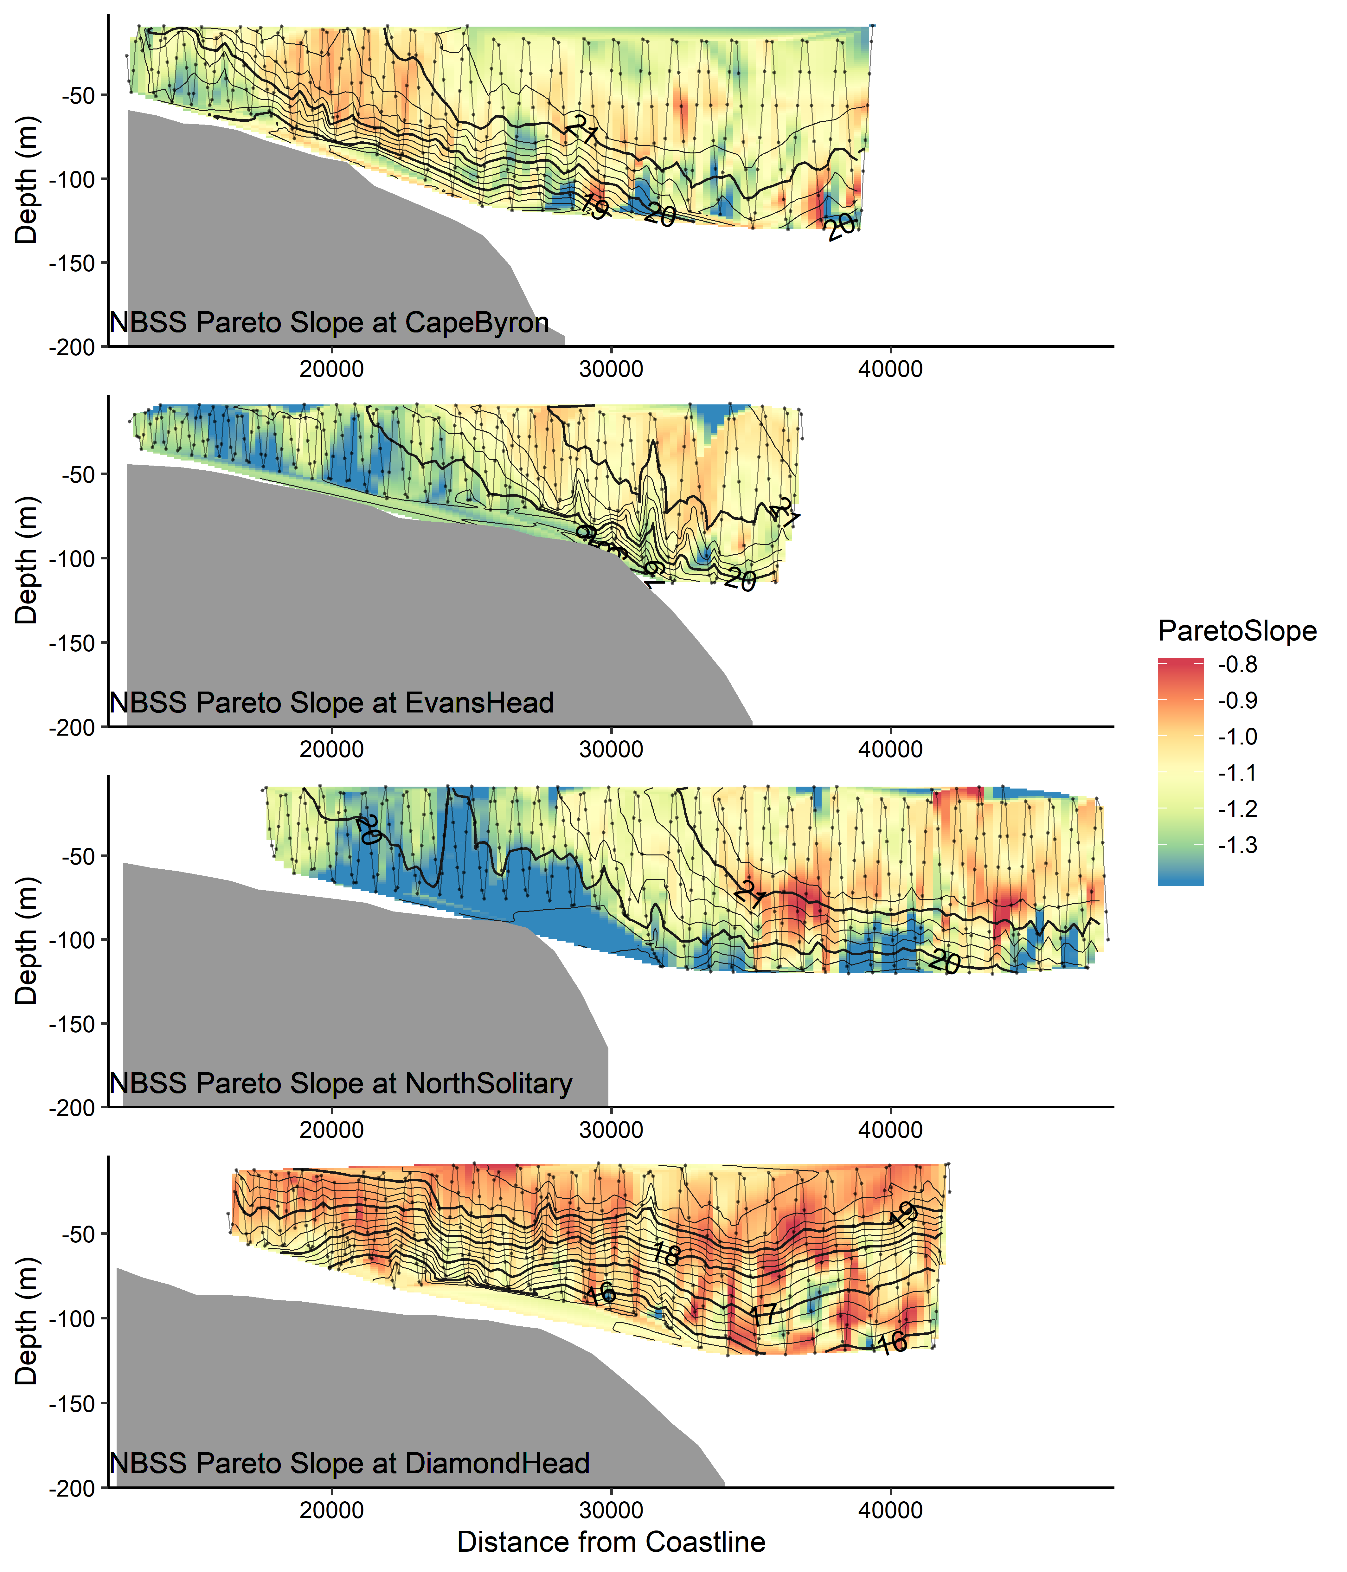

Figure 5. Interpolations of the Normalised Biomass Size Spectrum slope, estimated using the Pareto method from the four cross shelf transects (Figure 1). Transects were conducted form inshore to offshore with an undulating towed body with the path shown by the grey line with midpoints of each sample shown as dots. Temperature (° C) isotherms are shown in black. Note the log transformed colour scale. COUPLE OF DUD DATA POINTS TO REMOVE ON SURFACE

Temporal Gradients and Occurrence Rates

The three northern sites which were heavily influenced by the EAC showed strong temperature gradients from inshore to offshore of approximately 1 °C between the cooler inner shelf water and the warmer EAC. In the ten years from 2004 – 2013 this temperature gradient occurred regularly between inshore and offshore waters, suggesting regular occurrence of the physical mechanisms observed in this study.

From 10 years of daily SST data, on average at our 3 northern sites (Cape Byron, Evans Head and North Solitary), there was a mean water temperature difference between inshore water and offshore water of 0.5, 1.3, and 1.1 °C respectively. A 1 °C temperature gradient was observed in the transects at three EAC influenced sites with a similar 1°C gradient is observed 23.6, 55.2 and 49.5% of the time at the three northern sites (Figure 6).

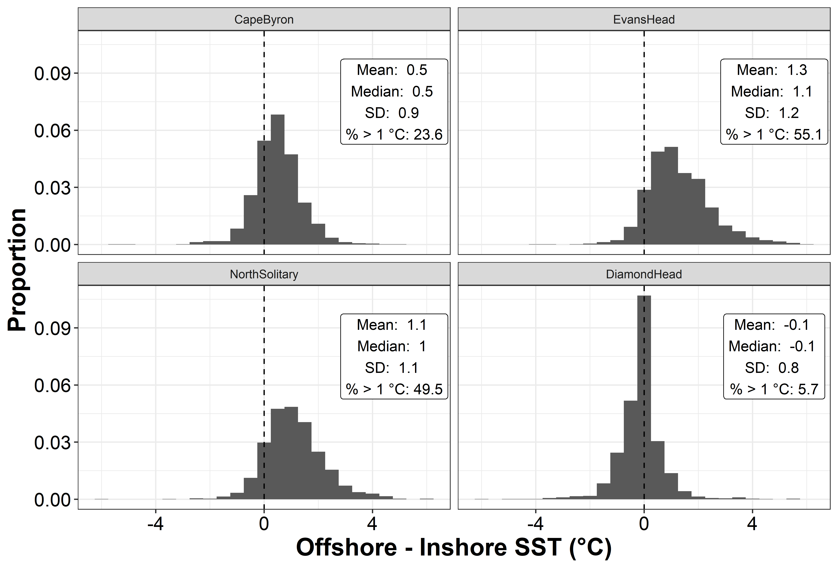

Figure 6. Distribution of temperature gradient at the 4 sites calculated as the offshore (45km from shore) SST minus the Inshore (15km from shore) SST for 10 years (2004 – 2013). The vertical dashed line marks no difference between inshore and offshore temperatures. If 5 km is used the percentage occurrence of a ≥1 °C difference increases at all sites. (SUPPLEMENTARY FIGURE)

The occurrence of this temperature gradient corresponded to increasing velocity observed from altimetry with larger temperature gradients tending to be observed during periods of higher along shelf velocity (Figure 7). When analysed by site, this pattern was evident at all three EAC influenced sites and not at the southernmost Diamond Head Site. The relationship was strongest at Evans Head and North Solitary where the EAC most often separates from the coastline resulting in cooler inner shelf water.

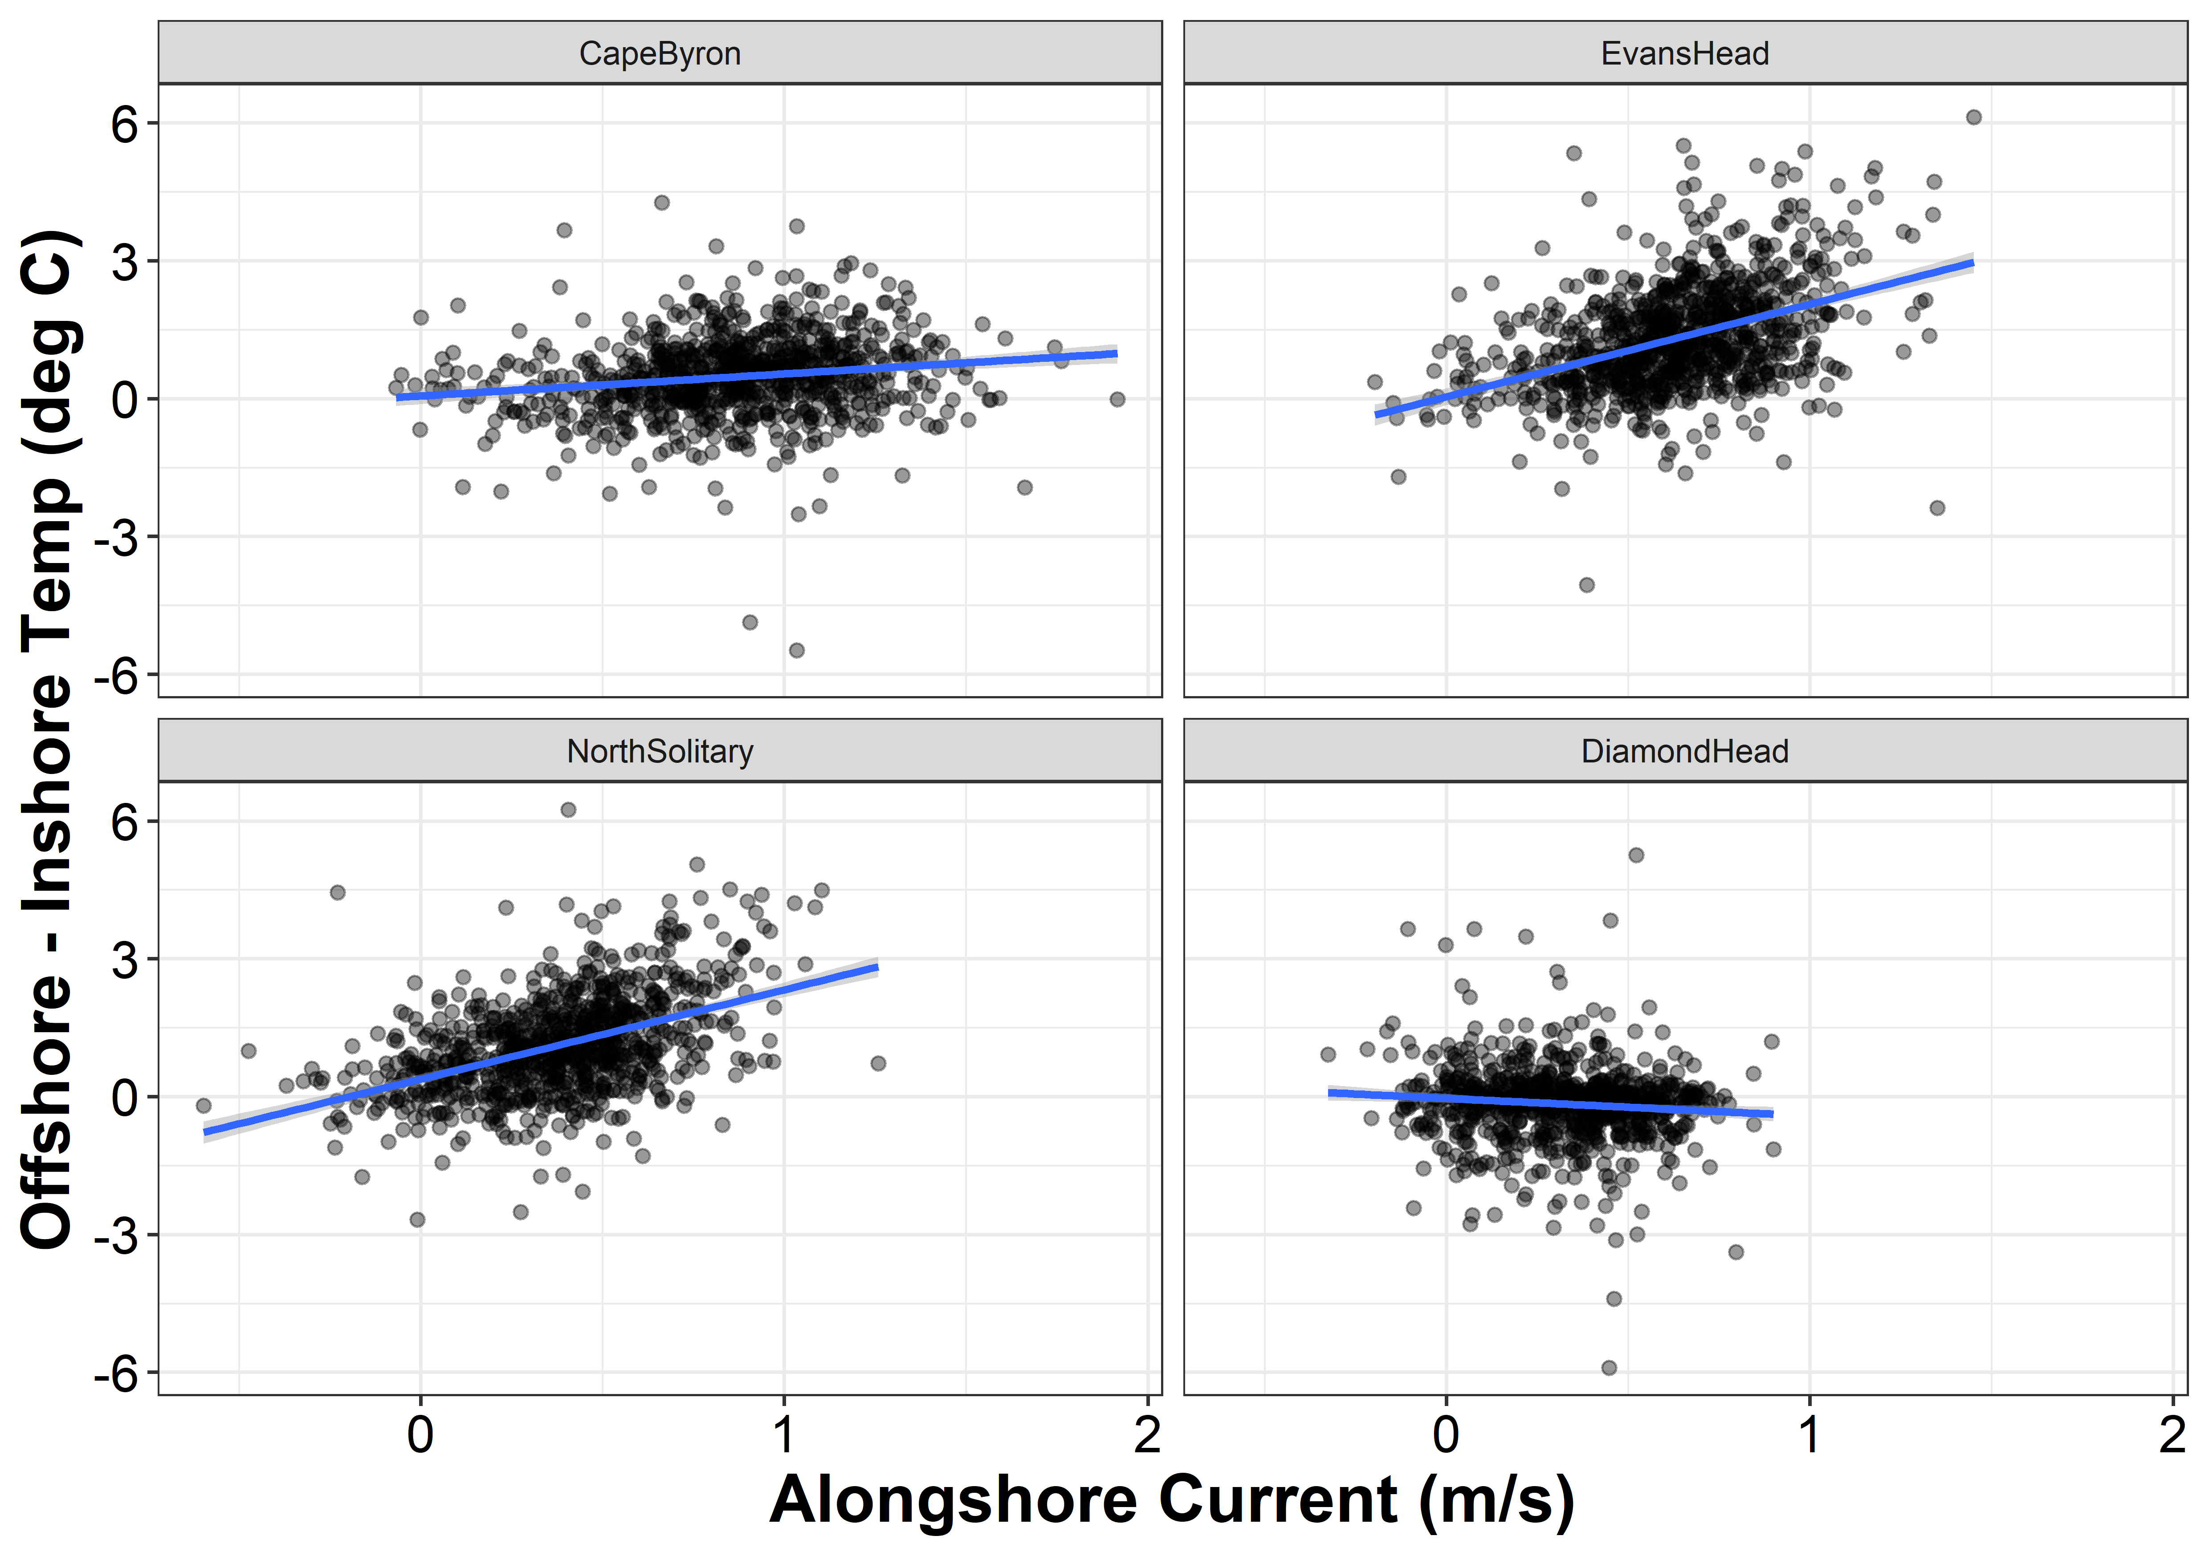

Figure 7. The relationship between alongshore velocity and the inshore-offshore temperature gradient at the 4 sites based upon 10 years of satellite data.

The occurrence of this 1 °C temperature gradient varied seasonally at the three northern EAC influenced sites with the 1 °C temperature gradient occurring less often in March and April and peaking in August through to November (Figure 8). No strong seasonal pattern was observed at Diamond Head.

Figure 8. Mean percentage of time that a 1 °C or greater temperature difference is observed between inshore and offshore waters at the locations of our transects for each month of the year. Error bars show standard deviation and data is based on daily SST measurements from 2004 – 2013.

Discussion

The shift in the zooplankton community moving from inshore to offshore in this western boundary current influenced location highlights the importance of recognising the inner continental shelf region as a distinct oceanographic region with different biological processes compared the open ocean. Due to the influence of the fast flowing EAC we observed an inner-shelf community with higher biomass, smaller geometric mean size and steeper normalised biomass size spectrum slope compared to the offshore community. These features together suggest higher productivity and increased predation in these areas compared to the communities off the continental shelf. This increased productivity driven by the uplift of the cooler water is likely an important driver for fisheries on the continental shelf region.

**Comparison to other studies**

All sites in this study showed there was a strong decline in biomass with both increasing distance from shore and depth with the largest biomasses observed in the upper inner shelf waters. This is similar to previous work which has shown continental shelf locations in the southeast Atlantic, northeast Atlantic and southwest Atlantic have higher biomasses compared to the offshore locations. While the northeast Atlantic pattern was attributed variable hydrology and topography, particularly over the shelf break (*Irigoien et al.*, 2008; *Sourisseau and Carlotti*, 2006; *Vandromme et al.*, 2014), in the southeast Atlantic, in the Brazilian Bight, this increase in inshore plankton concentrations was attributed to bottom intrusions of cooler nutrient rich South Atlantic Central Water (*Pereira Brandini et al.*, 2014). Slightly to the south, similar results were observed on the Abrolhos Bank with larger zooplankton biomasses observed on the continental shelf (*C d R Marcolin et al.*, 2013). This was attributed to the Brazilian Current interacting with the topography, generating uplift and eddies which increased mixing over the continental shelf (*C d R Marcolin et al.*, 2013). This is a similar situation to the EAC interacting with the topography in the current study. This consistent observation of high zooplankton biomass and steeper NBSS slopes inshore on continental shelves highlights the broad importance of the continental shelf regions for productivity.

While this current driven uplift explains the higher productivity and therefore biomass found in the sites which were influenced by the EAC as it pushed cooler nutrient rich water onto the continental shelf, the pattern of increased biomass on the continental shelf was also observed on at the Diamond Head, Tasman Sea dominated transect although with larger particles and shallower NBSS slope. The Tasman sea is known to have higher nutrient content and generally hold higher amounts of zooplankton compared to the oligotrophic EAC waters which explains the high biomass overall but the cause of the declining gradient with distance offshore is uncertain, it is possible that the zooplankton are being retained on the continental shelf by a physical mechanism or it is possible that there are more nutrients closer to shore as there are larger anthropogenic inputs. The larger geometric mean size and a shallower NBSS slope suggest that the Tasman Sea dominated southern site potentially has low predation relative to the other transects as the biomass was the highest observed of all transects.

**Implication for the future**

Climate change is driving substantial change in the EAC region with the flow strengthening by up to 35 % (*Sun et al.*, 2012), and separation occurring further south (*Cetina-Heredia et al.*, 2014). The faster flowing EAC may result in increased uplift of cooler nutrient rich water onto the continental shelf via current driven upwelling (*Roughan and Middleton*, 2002). With the EAC pushing further south before it separates from the coast, it may generate increased uplift in regions which currently have low levels of current driven uplift. On the other hand, the increasing water temperatures in the southeast Australian region are already impacting the zooplankton communities as the region becomes increasingly tropicalised, forcing some species to shift southward as they reach thermal limits or change their reproductive patterns (*Kelly et al.*, 2016). These changes may have significant effects on the overall distribution of zooplankton biomass, size structure and community composition on continental shelves as zooplankton are impacted across the globe in similar ways (*Richardson*, 2008).

**Limitations**

This study was based upon a single voyage which completed targeted cross-shelf transects to investigate the zooplankton communities in upwelling favorable regions. This means that the distributions observed in these transects represent a snapshot and it is possible that the patterns seen may vary from what we observed. Despite this, our analysis of temporal occurrence showed that the oceanographic conditions observed on this voyage are common for this region and that while we did not observed the zooplankton over time, the oceanographic conditions are not a unique occurrence. Despite this, our observed inshore-offshore gradient in zooplankton biomass did match those seen in other continental shelf regions around the world which supports the idea that the patterns we observed are representative of larger time scales.

While our study is the first to look at depth patterns of zooplankton across a continental shelf, due to limitations of the Bunyip, it did not sample in areas where the bathymetry was less than 50 m. This means that the true inshore water masses which may be heavily influenced by waves and interactions with the shore may have differing patterns in terms of the zooplankton community. In calculating the temporal occurrence of the inshore offshore temperature gradient, we used distances from the coast which corresponded to the limits of the transects taken with the OPC. If we used an inshore site only 5km from the coast (rather than 15 km) the mean temperature gradients were generally higher with 1.0 °C at Cape Byron, 1.7 °C at Evan Head and 1.5 °C at North Solitary while the Diamond head site did not change (-0.1 °C; FIGURE SUPP). This is due to the inshore site being located further away from the core of the EAC and more likely to highlight any cooler inshore water. If the 5km inshore site was used in the correlation between alongshore velocity and the temperature gradient the observed positive relationship remained at the three northern EAC dominated sites although was slightly stronger at Cape Byron (FIGURE SUPP). Using the 5km inshore data to investigate the seasonal trends also showed similar but higher patterns of occurrence for all sites except for Cape Byron which had a much larger increase in occurrence across all months except February & March which were roughly the same due to the EAC flooding the area and creating low chance of a temperature gradient in these months.

5 Conclusions

This study provides the first insight into the vertical and horizontal distribution of continental shelf zooplankton. By comparing zooplankton communities in the EAC influenced region with the more southern region which is not influenced by the EAC we showed how current driven uplift creating a highly productive inner-shelf water zooplankton community. It is likely that this is reflective of other western boundary current systems where similar horizontal patterns of zooplankton biomass have been observed. Based upon the previous research into zooplankton distributions on continental shelfs and the current study we would like to propose a number of hypotheses for future studies to test. 1) Zooplankton biomass (and abundance) declines with distance offshore and with depth. 2) Continental shelf waters are more productive that offshore waters, and 3) Western Boundary Currents drive productivity on the shelf through mixing and uplift. Future studies could answer these questions with more sustained monitoring of cross-shelf patterns throughout the year which has not previously occurred with all previous studies presenting only snapshots of cross-shelf patterns due to defined sampling seasons or irregular research voyages.

**References**

Aarflot, J. M., D. L. Aksnes, A. F. Opdal, H. R. Skjoldal, and O. Fiksen (2019), Caught in broad daylight: Topographic constraints of zooplankton depth distributions, *Limnology and Oceanography*, *64*(3), 849-859, doi:10.1002/lno.11079.

Armbrecht, L. H., M. Roughan, V. Rossi, A. Schaeffer, P. L. Davies, A. M. Waite, and L. K. Armand (2014), Phytoplankton composition under contrasting oceanographic conditions: Upwelling and downwelling (Eastern Australia), *Continental Shelf Research*, *75*, 54-67, doi:<https://doi.org/10.1016/j.csr.2013.11.024>.

Armbrecht, L. H., P. A. Thompson, S. W. Wright, A. Schaeffer, M. Roughan, J. Henderiks, and L. K. Armand (2015), Comparison of the cross-shelf phytoplankton distribution of two oceanographically distinct regions off Australia, *J. Mar. Syst.*, *148*, 26-38, doi:10.1016/j.jmarsys.2015.02.002.

Baird, M. E., P. G. Timko, J. H. Middleton, T. J. Mullaney, D. R. Cox, and I. M. Suthers (2008), Biological properties across the Tasman Front off southeast Australia, *Deep-Sea Res. Part I-Oceanogr. Res. Pap.*, *55*(11), 1438-1455, doi:10.1016/j.dsr.2008.06.011.

Barnes, C., D. Maxwell, D. C. Reuman, and S. Jennings (2010), Global patterns in predator–prey size relationships reveal size dependency of trophic transfer efficiency, *Ecology*, *91*(1), 222-232, doi:10.1890/08-2061.1.

Blanchard, J. L., R. F. Heneghan, J. D. Everett, R. Trebilco, and A. J. Richardson (2017), From Bacteria to Whales: Using Functional Size Spectra to Model Marine Ecosystems, *Trends Ecol. Evol.*, *32*(3), 174-186, doi:10.1016/j.tree.2016.12.003.

Cetina-Heredia, P., M. Roughan, E. van Sebille, and M. A. Coleman (2014), Long-term trends in the East Australian Current separation latitude and eddy driven transport, *Journal of Geophysical Research: Oceans*, *119*(7), 4351-4366, doi:10.1002/2014jc010071.

Champion, C., I. M. Suthers, and J. A. Smith (2015), Zooplanktivory is a key process for fish production on a coastal artificial reef, *Marine Ecology Progress Series*, *541*, 1-14, doi:10.3354/meps11529.

GEBCO Bathymetric Compilation Group (2019), The GEBCO_2019 Grid - a continuous terrain model of the global oceans and land., edited by N. O. C. British Oceanographic Data Centre, NERC, UK doi:10/c33m

Herman, A. W. (1992), Design and calibration of a new optical plankton counter capable of sizing small zooplankton, *Deep Sea Research Part A. Oceanographic Research Papers*, *39*(3), 395-415, doi:<https://doi.org/10.1016/0198-0149(92)90080-D>.

Huntley, M. E., A. GonzÃÂ¡lez, Y. Zhu, M. Zhou, and X. Irigoien (2000), Zooplankton dynamics in a mesoscale eddy-jet system off California, *Marine Ecology Progress Series*, *201*, 165-178.

Irigoien, X., J. A. Fernandes, P. Grosjean, K. Denis, A. Albaina, and M. Santos (2008), Spring zooplankton distribution in the Bay of Biscay from 1998 to 2006 in relation with anchovy recruitment, *Journal of Plankton Research*, *31*(1), 1-17, doi:10.1093/plankt/fbn096.

Kelly, P., L. Clementson, C. Davies, S. Corney, and K. Swadling (2016), Zooplankton responses to increasing sea surface temperatures in the southeastern Australia global marine hotspot, *Estuarine, Coastal and Shelf Science*, *180*, 242-257, doi:<https://doi.org/10.1016/j.ecss.2016.07.019>.

Kerr, S. R., and L. M. Dickie (2001), *The biomass spectrum: a predator-prey theory of aquatic production*, Columbia University Press.

Libralato, S., V. Christensen, and D. Pauly (2006), A method for identifying keystone species in food web models, *Ecological Modelling*, *195*(3), 153-171, doi:<https://doi.org/10.1016/j.ecolmodel.2005.11.029>.

Malan, N., M. Archer, M. Roughan, P. Cetina-Heredia, M. Hemming, C. Rocha, A. Schaeffer, I. Suthers, and E. Queiroz (2020), Eddy-Driven Cross-Shelf Transport in the East Australian Current Separation Zone, *Journal of Geophysical Research: Oceans*, *125*(2), e2019JC015613, doi:10.1029/2019jc015613.

Marcolin, C., R. Lopes, and G. Jackson (2015), Estimating zooplankton vertical distribution from combined LOPC and ZooScan observations on the Brazilian Coast, *Mar. Biol.*, *162*(11), 2171-2186, doi:10.1007/s00227-015-2753-2.

Marcolin, C. d. R., S. Schultes, G. A. Jackson, and R. M. Lopes (2013), Plankton and seston size spectra estimated by the LOPC and ZooScan in the Abrolhos Bank ecosystem (SE Atlantic), *Continental Shelf Research*, *70*, 74-87, doi:<https://doi.org/10.1016/j.csr.2013.09.022>.

Marquis, E., N. Niquil, A. F. Vézina, P. Petitgas, and C. Dupuy (2011), Influence of planktonic foodweb structure on a system's capacity to support pelagic production: an inverse analysis approach, *ICES J. Mar. Sci.*, *68*(5), 803-812, doi:10.1093/icesjms/fsr027.

Oke, P. R., et al. (2019), Revisiting the circulation of the East Australian Current: Its path, separation, and eddy field, *Prog. Oceanogr.*, *176*, 102139, doi:<https://doi.org/10.1016/j.pocean.2019.102139>.

Pereira Brandini, F., M. Nogueira, M. Simião, J. Carlos Ugaz Codina, and M. Almeida Noernberg (2014), Deep chlorophyll maximum and plankton community response to oceanic bottom intrusions on the continental shelf in the South Brazilian Bight, *Continental Shelf Research*, *89*, 61-75, doi:<https://doi.org/10.1016/j.csr.2013.08.002>.

Richardson, A. J. (2008), In hot water: zooplankton and climate change, *ICES J. Mar. Sci.*, *65*(3), 279-295, doi:10.1093/icesjms/fsn028.

Rossi, V., A. Schaeffer, J. Wood, G. Galibert, B. Morris, J. Sudre, M. Roughan, and A. M. Waite (2014), Seasonality of sporadic physical processes driving temperature and nutrient high-frequency variability in the coastal ocean off southeast Australia, *Journal of Geophysical Research: Oceans*, *119*(1), 445-460, doi:10.1002/2013jc009284.

Roughan, M., H. S. Macdonald, M. E. Baird, and T. M. Glasby (2011), Modelling coastal connectivity in a Western Boundary Current: Seasonal and inter-annual variability, *Deep-Sea Res. Part II-Top. Stud. Oceanogr.*, *58*(5), 628-644, doi:10.1016/j.dsr2.2010.06.004.

Roughan, M., and J. H. Middleton (2002), A comparison of observed upwelling mechanisms off the east coast of Australia, *Continental Shelf Research*, *22*(17), 2551-2572, doi:10.1016/s0278-4343(02)00101-2.

Sourisseau, M., and F. Carlotti (2006), Spatial distribution of zooplankton size spectra on the French continental shelf of the Bay of Biscay during spring 2000 and 2001, *Journal of Geophysical Research: Oceans*, *111*(C5), doi:10.1029/2005jc003063.

Sun, C., M. Feng, R. J. Matear, M. A. Chamberlain, P. Craig, K. R. Ridgway, and A. Schiller (2012), Marine Downscaling of a Future Climate Scenario for Australian Boundary Currents, *J. Clim.*, *25*(8), 2947-2962, doi:10.1175/jcli-d-11-00159.1.

Suthers, I. M., C. T. Taggart, D. Rissik, and M. E. Baird (2006), Day and night ichthyoplankton assemblages and zooplankton biomass size spectrum in a deep ocean island wake, *Marine Ecology Progress Series*, *322*, 225-238.

Truong, L., I. M. Suthers, D. O. Cruz, and J. A. Smith (2017), Plankton supports the majority of fish biomass on temperate rocky reefs, *Mar. Biol.*, *164*(4), 12, doi:10.1007/s00227-017-3101-5.

Turner, J. T., and M. J. Dagg (1983), Vertical Distributions of Continental Shelf Zooplankton in Stratified and Isothermal Waters, *Biological Oceanography*, *3*(1), 1-40, doi:10.1080/01965581.1983.10749470.

Vandromme, P., E. Nogueira, M. Huret, Á. Lopez-Urrutia, G. G.-N. González, M. Sourisseau, and P. Petitgas (2014), Springtime zooplankton size structure over the continental shelf of the Bay of Biscay, *Ocean Science*, *10*, 821-835.

Vidondo, B., Y. T. Prairie, J. M. Blanco, and C. M. Duarte (1997), Some aspects of the analysis of size spectra in aquatic ecology, *Limnology and Oceanography*, *42*(1), 184-192, doi:10.4319/lo.1997.42.1.0184.